Introduction to databases

Q1

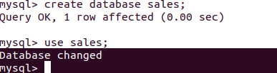

Q2

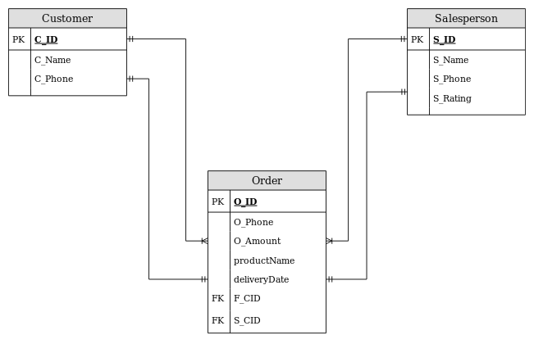

Q3

create table customer(c_id int primary key, c_name varchar(160),c_phone bigint(10));

create table sales_person(s_id int primary key,s_name varchar(160),S_phone bigint(10));

create table order_details(o_id int primary key,product_name varchar(160),o_amount float(7),delivery_date datetime,f_cid int,f_sid int,foreign key(f_cid) references customer(c_id),foreign key(f_sid) references sales_person(s_id));

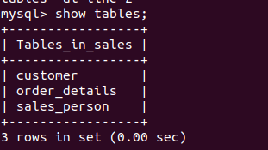

Q4

insert into customer values (1,"Dany",8858537901),(2,"naki",9105616702),(3,"neni",786059531),(4,"Ankur",6388779533);

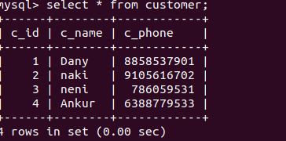

insert into sales_person values(1,"Ammar",9876123405),(2,"Shayan",78607366887),(3,"Kaushlendra",6393127856),(4,"Fahad",7851875502);

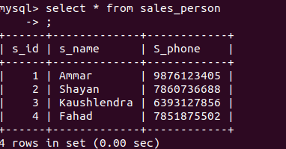

insert into order_details values(1,"Water Bottle",90.5,now(),1,3);

insert into order_details values(2,"Shoes",5590.57,now(),2,4),(3,"Dress",350,now(),1,3);

insert into order_details values(5,"Mink Blanket",8590.57,now(),1,1),(6,"Laptop",23500.00,now(),3,4),(7,"Lock",100.10,now(),4,3);

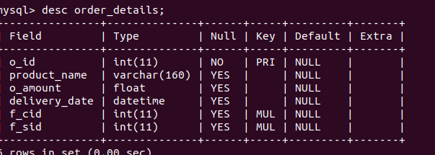

Q5

select s.s_id,s.s_name from sales_person s inner join order_details o on s.s_id=o.f_sid group by s_id having count(s_id)>1;

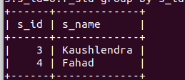

Q6

select o.o_id,o.product_name,s.s_id,s.s_name from sales_person s inner join order_details o on s.s_id=o.f_sid;

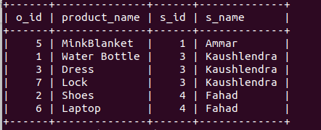

Q7



Q8

show index from sales_person\G;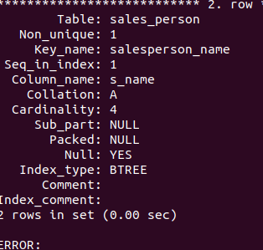

Q9

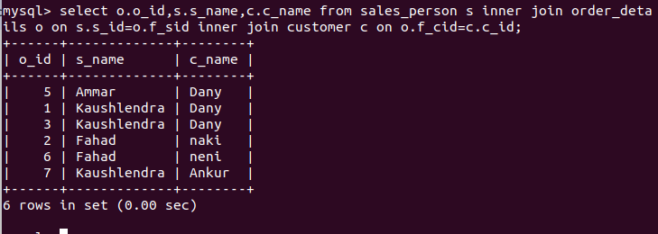

select o.o_id,s.s_name,c.c_name from sales_person s inner join order_details o on s.s_id=o.f_sid inner join customer c on o.f_cid=c.c_id;